Exercises: 1. Basis Introduction into Catalysis
- Draw a schematic energy profile of an uncatalyzed and a catalyzed reaction and explain why the catalyzed reaction is faster using also the Arrhenius equation.
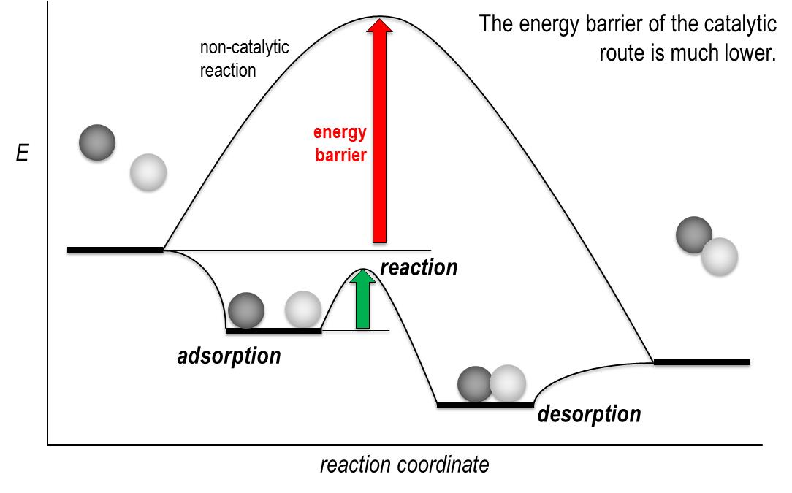
Activation barrier E_{a} of a catalyzed reaction is lower than for an uncatalyzed reaction. The Arrhenius equation 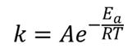describes the relationship between activation energy and reaction rate. Lower E_{a} => higher rate for given T.

- The molecular orbital (MO) theory is a suitable tool to illustrate the adsorption of molecules on the surface of heterogeneous catalysts. Please draw schematically the adsorption of a CO molecule on a d-metal using the MO theory and explain in note form by means of the scheme the adsorption of the CO molecule and the electron “back donation” effect.
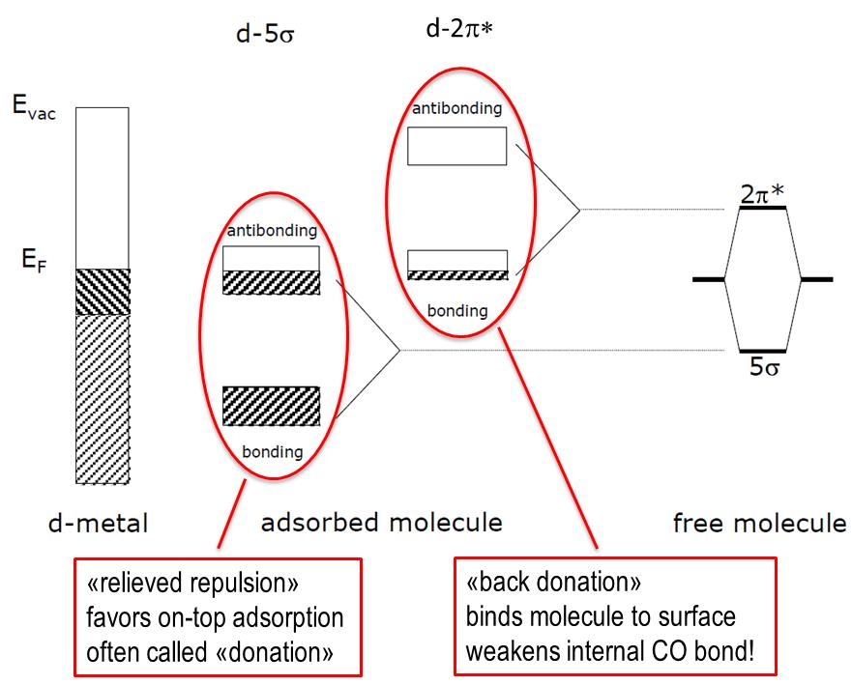

- How does the back donation influence the wave number (or frequency) in the IR spectrum of CO adsorbed on a d-metal compared to free CO in the gas phase and why?
IR frequency of adsorbed CO is lowered, mainly due to electron back donation into its 2p* orbital. This weakens the CO bond resulting in a slower vibration.

